Camp 127 (& 296) - Potter's Hill, High Green, Sheffield, Yorkshire

Included in the 1945 ICRC camp list – Labour Camp. 127. Potters Hill Camp, High Green, Sheffield.

1947 Camp list
296(G.W.C.) | Potters Hill Camp, High Green, Sheffield | N. | Priswar, High Green | High Green 77 | (Blank) | Lt.Col. W.J.Arnold | v/1453/2

Prisoner of War Camps (1939 – 1948) - Project report by Roger J.C. Thomas - English Heritage 2003
OS NGR | Sheet | No. | Name & Location | County | Cond’n | Type 1945 | Comments
SK 33 97 | 111 | 127 | Potter's Hill, High Green, Sheffield | Yorkshire | 5 | German Working Camp | See Camp no.296

Location: The above NGR is a general location. The camp was located at SK 334 970.  Before the camp: In 1936, fields. “Memoirs of local resident Catherine Chalmers (later Reed?) record that the camp was initially constructed by the British Army and only later was handed over to the Americans. Following their departure the site became a POW Camp.” https://www.americanairmuseum.com/archive/place/potters-hill  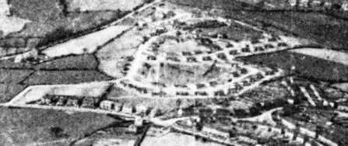  Pow Camp: Listed as Italian collaborator working camp / labour battalion to at least late 1945, then a German Working Camp.  November 1944 - The camp was listed as an Italian Labour Battalion, (WO 32/10737).  1 August 1945 - an urgent memorandum was sent to this camp, and others, about maintaining records of Italians who were classed as ‘co-operators’. At this point many, sometimes all, of the Italian pows were in hostels / billets.  14 November 1945 - The camp was inspected by the International Red Cross; report at end.  Various memories of the camp (https://www.sheffieldforum.co.uk/) – | 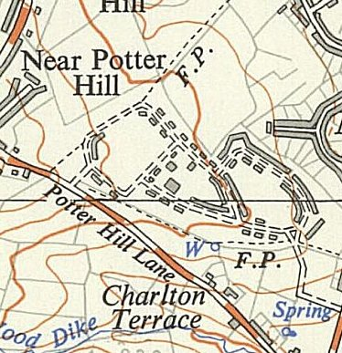
 | Ordnance Survey 1951

“I was told by the older locals that the camp was used to billet American soldiers prior to D Day, and then used as a prison camp for Italian prisoners.”

“I had heard that the Italians painted the inside of St Mary’s Church [just off the map NE corner] and that when the Americans were there they used to go training in Westwood.”

“One of the Italian pow's jobs was concreting the roads that were to become the (New) Parson Cross estate - the part that is near Ecclesfield -“

“There were German prisoners there for a short while, until 3 of them did a runner, they were caught about a mile down the road by a local bobby.”

19 May 1946 – First edition of the camp magazine - Der Hugel : Potters Hill Camp : Lagerzeitung der Deutschen Kriegsgefangenen POW Camp 127 - The Wiener Holocaust Library

Camp leader; Dr Rudolf Teubert

1947 - a small detachment of 12 German pows was located here, working with No.1 Bomb Disposal Squadron. The main HQ for the pows with 1 BDS was at Bunny Camp, a hostel for Langar Camp 262.

At some point the camp number changed from 127 to 296 – a number which had previously been used by Ravenfield.

December 1947 / January 1948 – there was a chance for some pows from this and other camps to attend extra-mural courses at Sheffield University. For 1 month starting 23 January, pows were brought to live at Potters Hill, they would work during the day and attend evening courses at the University.

There were 2 camp magazines – Die Fähre (The Ferry) and Der Hűgel (The Hill). According to one article one paper was issued on the first day of the month for serious readers, the second was in ‘tabloid’ form with lighter reading published mid-month. [German Historical Institute London Bulletin, Vol XXX, No.2, November 2008 by Ingeborg F. Hellen – “The boys’ own papers: the case of German pow camp newspapers in Britain, 1946-8].

Known Camp Commandants:
1945 Major R Coolhurst
1947 Lt Col W J Arnold, from the East Lancashire Regiment.

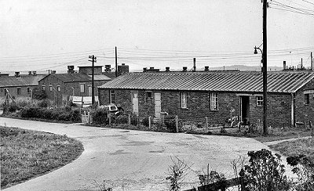 | After the camp: Used for emergency housing. 2019 residential area.  Further Information:  The German Federal Archives have copies of the camp magazines.  Pictures taken 21/09/1964 - Images used with the kind permission of Sheffield Newspapers Ltd –  Ref Nos s25595 / s25596 | 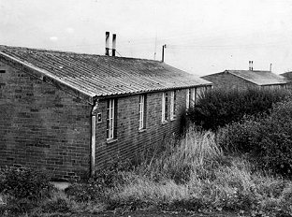

POW NUMBERS

 |  | Open |  |  | With other camps |  |  | Unknown |  |  | Not open

 | 1944 | 1945 | 1946 | 1947
Potters Hill HQ |  | 392
Barnsley Road, Doncaster |  | 74 | With C296
High Melton |  | 240
Hoyland | 1943 – With C17 | 71 | With C296
Thrybergh |  | 222
Woolley | 1943 – With C17 | 80 | With C91
Billets |  | 55
Other |  | 11 in hospital |  | 12 detached from C262
TOTALS |  | 1145
Hostels: (Note – some entries for Potter’s Hill refer to it as Bracken Hill Camp, but they were separate sites).

Barnsley Road, Doncaster. On Barnsley Road, Scawsby, opposite St. Leonard's church – NGR SE 552 049.  1945 – Hostel leaders; TIOLI Eliodoro, “S/Mj.” 497822 / TROIANO Ciro, “Sjt.” 285559  March 1946 – listed with Ravenfield Camp 296. | 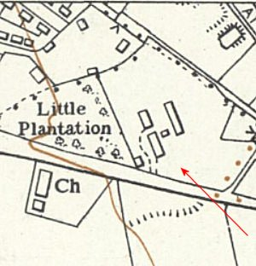
 | Ordnance Survey 1956

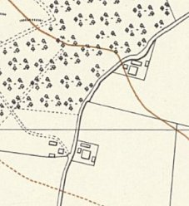 | < High Melton (Possible site mentioned for Sheep Lane, next to Melton Wood and Sheep Lane Farm – NGR SE 515 030)  1945 – Hostel leaders; NICOLODI Eligio, “Maresc.” 240949 / BRIGANTE Antonio, “S/Mj.” 81788.  Hoyland (Common).  1943 - listed as a hostel for Lodge Moor Camp 17 with Italian pows.  1945 – listed as a hostel for Potters Hill Camp 127. Hostel leaders; BARROI Mario, “S/Mj.” 122522 / DI MAURO Rocco, “Sjt.” 118912  1946 – listed with Ravenfield Camp 296
Ordnance Survey 1956

Thrybergh

Possibly what was Camp 785 AA Camp, Thrybergh, Rotherham, Yorkshire.

1945 – Hostel leaders; NEGRO Giuseppe, “Maresc.” 495584 / TEDESCO Michele, “S/Mj.” 49809.

Woolley. SE 305 147

1943 - listed as a hostel for Lodge Moor Camp 17 with Italian pows.

1945 – listed as a hostel for Potters Hill Camp 127. Hostel leaders; RAGO Fedele, “S/Mj.” 209660 / SPOSITO Luigi, “Sjt.” 209665

1946 – listed with Post Hill Camp 91.

Working Battalion 127 (Italians)  Visited on 14 November 1945 by M. de Watteville  Camp Address: Italian Labour Camp 127  Commandant: Major R Coolhurst & Adj. Lieutenant Slack  Camp Leaders:  Potters Hill de MARO M. “Marescallo” No 175897  TOMMASINI F. “SM” 497831  High Melton NICOLODI Eligio, “Maresc.” 240949  BRIGANTE Antonio, “S/Mj.” 81788  Thrybergh NEGRO Giuseppe, “Maresc.” 495584  TEDESCO Michele, “S/Mj.” 49809  Woolley RAGO Fedele, “S/Mj.” 209660  SPOSITO Luigi, “Sjt.” 209665  Hoyland BARROI Mario, “S/Mj.” 122522  DI MAURO Rocco, “Sjt.” 118912  Barnsley Rd. Camp TIOLI Eliodoro, “S/Mj.” 497822  Doncaster TROIANO Ciro, “Sjt.” 285559  Italian Officers: BARSARELLI Tenente, chaplain 26050  MONDELLA Tenente, doctor 209065  Capacity: About 2000 men  Strength: 1145 Italian prisoners distributed in the following way:  Potters Hill 392  High Melton 240  Barnsley Road, Doncaster 74  Hoyland 71  Wooley 80  Thryberg 222  Living in local houses 55  In hospital 11  Prisoners working for the “Ministry of Supplies” 251  and the “Ministry of “War” 336  in agriculture 224  transportation 32  off work 3  ill 81  in transit 110  permanently with the camp 108 |  | The 240 prisoners of High Melton are warrant officers (sergeants and sergeants-major) who asked to work. This camp is also used as a repatriation centre (3000 prisoners of this category have passed through).  General  This camp, built at the beginning of the war by the municipality of Sheffield to place local people in case of air raids, is located on a hill ten kilometres from Sheffield.  The buildings are made of bricks and the kitchens and the refectories are very well arranged (steam, electricity, refrigerator, etc.) A large hut is used as a chapel or movie theatre.  Each of the 44 barracks contain 6 rooms, as well as W.C. and toilets.  For the prisoners who remain in the camp there are 9 beds per room, and for the prisoners in transit, 6. All areas are lit with electricity and are heated by small stoves. Fire-fighting equipment is in place. Bed linen is excellent and the prisoners have 8 bathtubs and showers, with hot water four times per week.  Food  No complaints were presented about food and up until now the reduction in rations has not had an unfavourable effect. Three meals are served per day. Men who work away from the camp take a packed lunch.  Menu for 14 November 1945:  Breakfast: milk, marmalade, bread  Lunch: tea, milk, and in camp; meat and potatoes.  For workers: sandwiches  Dinner: Pastes, peas, sausages and roast potatoes.  Medical care  The infirmary, very well managed at Potters Hill, is under the direction of the Italian lieutenant doctor who also visits the “hostel” at Thrylberg three times per week. The five other “hostels” are entrusted to local English doctors. The doctor lieutenant MONDELLA also works as dentist in a very well-equipped dentist’s surgery. He is assisted by 4 medical members of staff. The infirmary has 13 beds for patients, two isolation rooms and all the necessary buildings (two bathrooms, etc.).  The doctors state that health and nutrition is good. The relatively large number of patients of battalion 81 is explained by the fact that they are mainly prisoners being repatriated for health reasons and who are passing through the camp. Five to six patients are present at the daily medical visit. A medical examination takes place each month.

On November 14 1945, the following 5 cases were having treatment at the hospital;  strained foot  gastric  knee wounded by accident  problem with circulation  psychopathic.  There were no cases of epidemic or serious illness. A man committed suicide (by hanging) the day before being repatriated because he had received bad news from home. Twenty-seven prisoners, often sick, were declared suited for light work (office, etc.) by British doctors. Like all prisoners, the medical personnel are free in the evenings.  Clothing  The prisoners are very well dressed in clothing which is in good condition, the same for their shoes. They arrange their own cleaning, having sufficient hot water and soap.  Work and pay  Prisoners that work around the camp earn 9 to 10/- each week and can send to money to their families, but that takes a long time. They are transported to their work place, leaving the camp at 0700, to return at 1700. After dinner they are free until 2200.  Canteen  The prisoners have a canteen and in spite of the lack of goods and low prices, the “Welfare Fund” exceeds the £250 planned for a camp of this size. Each prisoner is given 35 cigarettes per week and can buy another 5.  Religious services  The chaplain rarely visits the different “hostels.” He regularly holds mass in the camp and exerts a good influence amongst the prisoners.  Leisure  The prisoners have a football field and footballs. They have also playing cards, jeux de dames, chess, etc. The library has approximately 250 volumes, but it does not seem possible to organise lessons. On the other hand, film shows take place twice per month (today, for the first time, an Italian film). |  | Correspondence  This works perfectly well. By paying 5d, the prisoners can send their letters by airmail.  Conclusion  Excellent camp in all respects. The head of camp and the 2 Italian officers did not have any complaints to raise.  5d = 5 pence/pennies = 2p.  (Translated by M Sanders 2010)

